WEBTECH LAB DOCUMENTATION

1. Our website utilizes salon services. In here, you can see that there are different salon services such as facials, make up, hair styling, and nails. This is the homepage of the website and in here you can search these different salon services where the customer can type a salon service at the search bar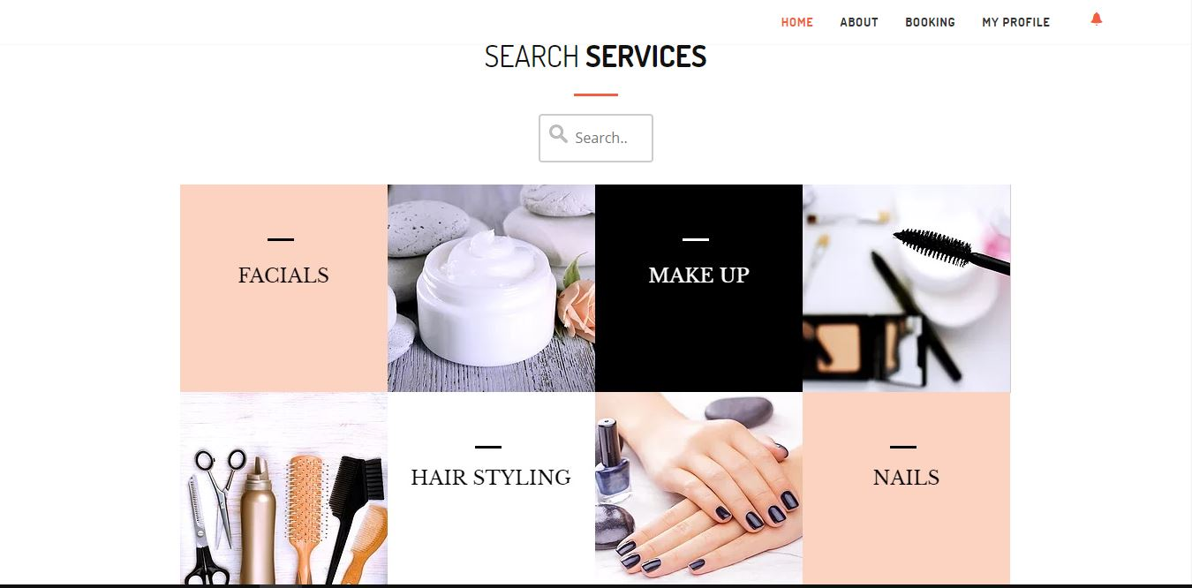
2. The interfaces as pictured above are where you can scroll these services as we also have searching services. The descriptions also describe a particular service, if the customer wants to request for a service. Customer can search for the service and the service providers will be provided through the search.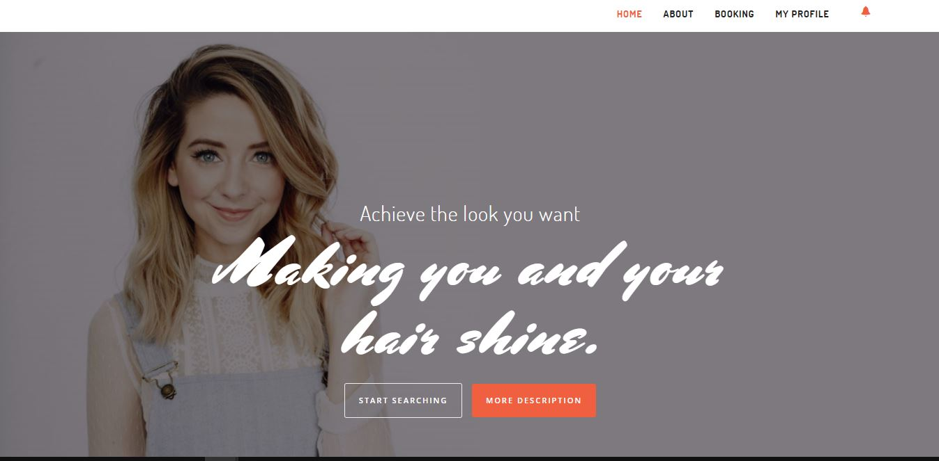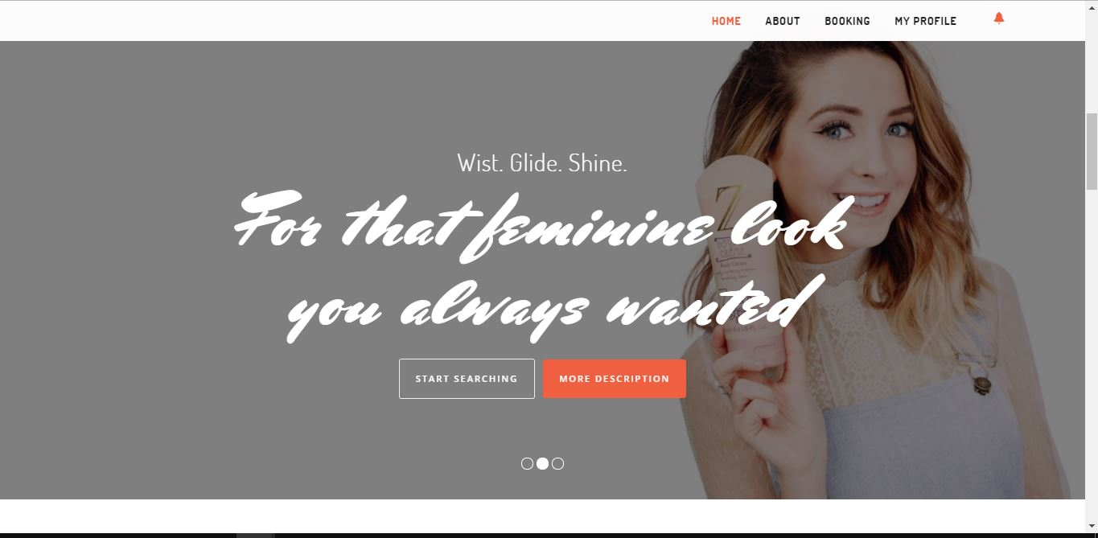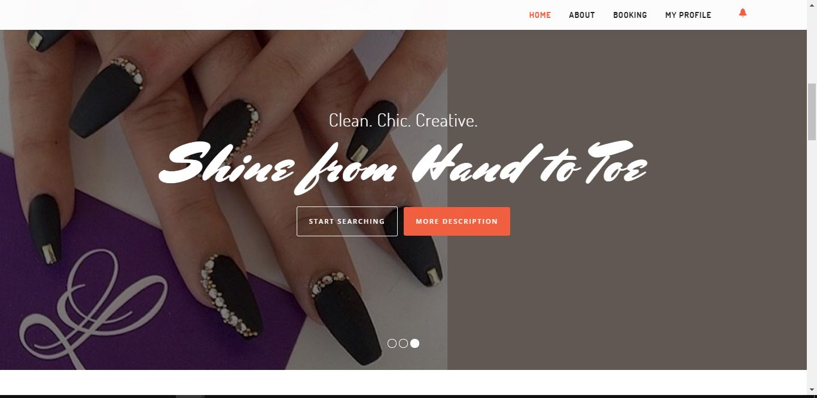
3. Once the customer clicks the “*MORE DESCRIPTIONS”* box they will be directed to the descriptions of a particular service they want to search with the use of the interface. 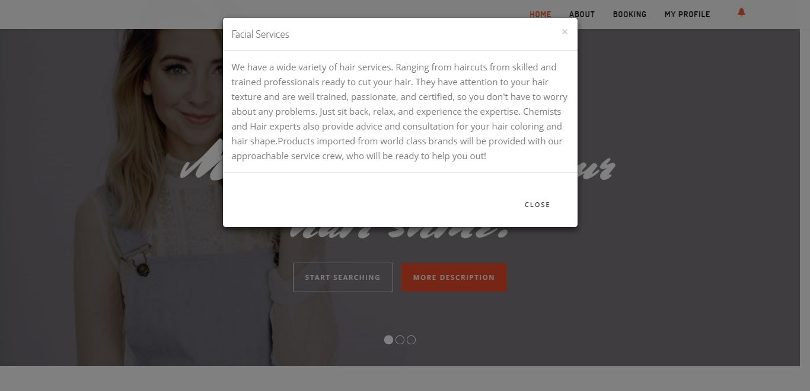
4. Now we move on to the “*ABOUT*” sections, this where the websites mission and vision is located.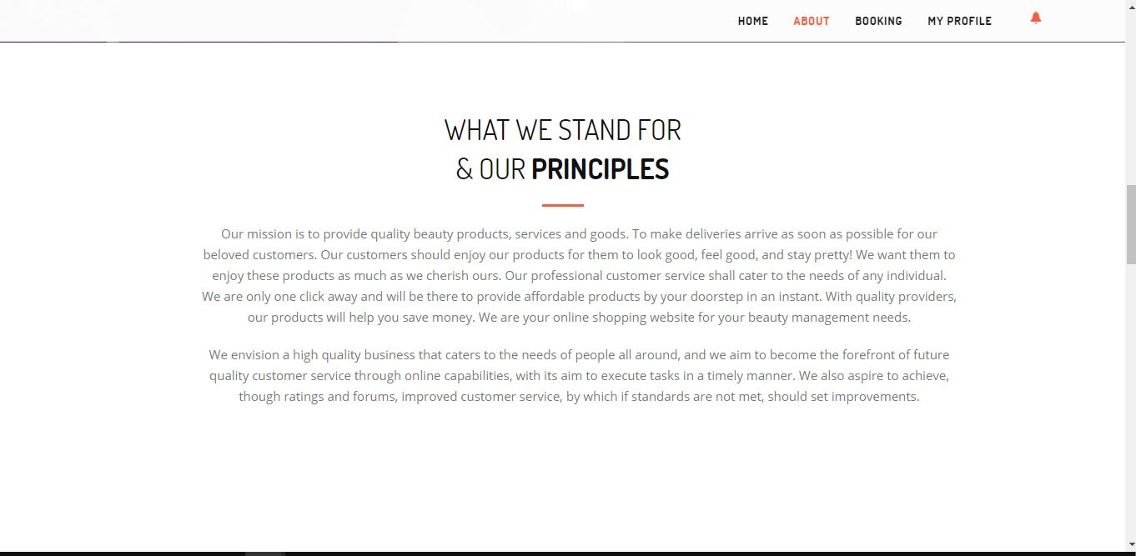
5. This where you can click these tags and the admin will redirect the customer to these media websites. As you can see above, we have Twitter, Facebook, Google, and WordPress. 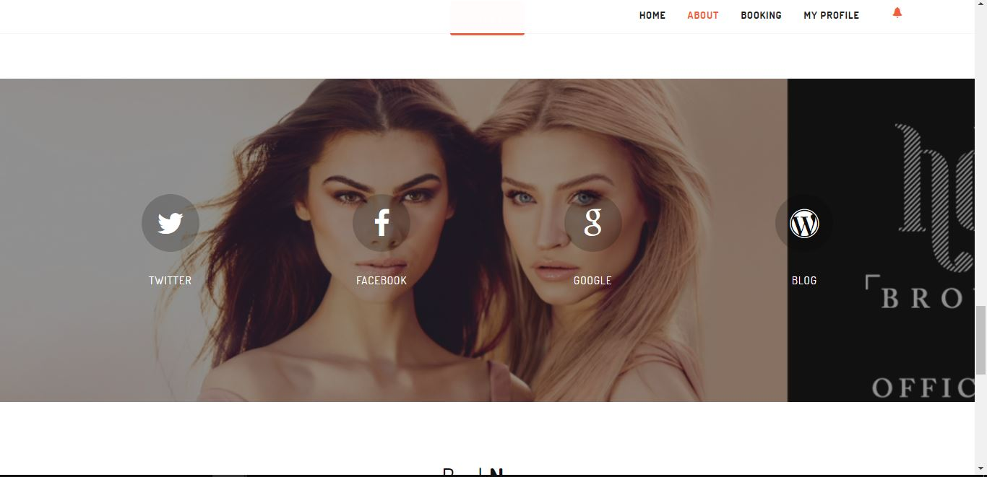
6. This is the booking section. This is where you can book the service, service provider, additional information, and schedule. The ones marked in an asterisk(\*) are required to fill in.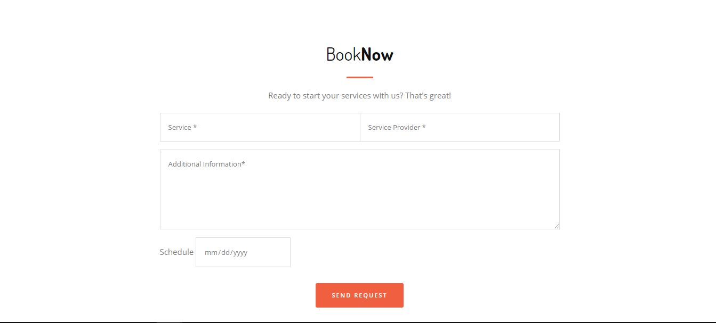

1. This is the Login page. The customer or service provider can login here, they just have to simply hover the mouse here and when they do hover the mouse to this circle here. 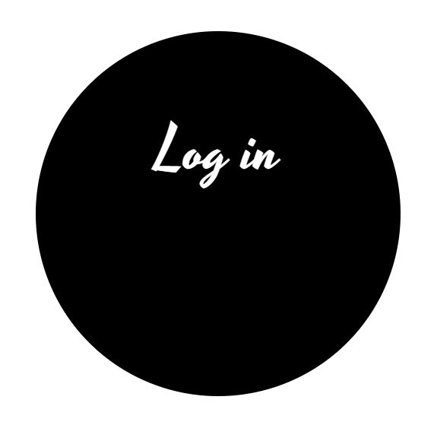
2. This is where the customer or service can now login their username and password as a customer or service provider.

